COMPANY PROFILE
Wiener Neudorf
23. Mai 2022

Lorem ipsum dolor sit amet…

Rückfragehinweis:
DI Wolfgang Berger, CEO
AVILOO GmbH
wolfgang.berger@aviloo.com
Tel.: +43 2236 374 036
WWW.AVILOO.COM

Wiener Neudorf
August 24th, 2023

Contact:
Radinka Danilov Sehovic,
Senior Expert Marketing & Communications
AVILOO GmbH
radinka.sehovic@aviloo.com
Tel.: +43 676 88932 209
WWW.AVILOO.COM

AVILOO FLASH TEST

YOUR BATTERY AT A GLANCE

The AVILOO FLASH test is a quick test that comprehensively determines the functionality of a traction battery.

Advantages:
- Fast: 3 minutes
The test takes only three minutes to perform. Above all, this speeds up the testing of a larger number of cars considerably. The AVILOO FLASH Test is therefore particularly attractive for professional users who carry out battery analyses for several vehicles.
- No driving required
The AVILOO FLASH test provides a comprehensive analysis of the functionality of the traction battery without having to move the vehicle - as is the case with the AVILOO PREMIUM Test, which provides an even deeper State of Health analysis. The FLASH Test is thus suitable for all those applications where the vehicle to be tested cannot be moved or can hardly be moved, for example in the case of lease returns.
- Independent AVILOO-Score
The manufacturer independent AVILOO score is determined by analysing a large amount of collected test data. In addition, battery historical data - such as total energy consumption, number of full cycles, driving behaviour, charging cycles, etc. - are interpreted by BIG DATA applications and integrated into the AVILOO score. The AVILOO score is thus a combination of current measured values and historical data.
The higher the score, the better the battery condition. A lower score implies increased risks for possibly necessary repairs and means a reduction in the value of the vehicle. In case of substantial risks, the FLASH test provides a "Red Flag" report.
- Multiple test categories and parameters
The AVILOO FLASH Test measures several parameters in different test categories: vehicle communication, battery controller, HV battery condition, low voltage system and battery history.

AVILOO FLASH Test process
The AVILOO FLASH Test is very simple to use: connect the AVILOO box to the vehicle's OBD interface and switch on the vehicle. Three minutes later, the result is there.

FLASH Test indicators:
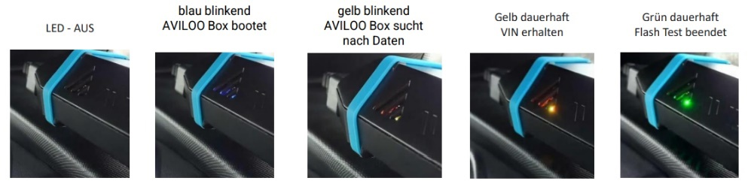
Wiener Neudorf
August 24th, 2023

Contact:
Radinka Danilov Sehovic,
Senior Expert Marketing & Communications
AVILOO GmbH
radinka.sehovic@aviloo.com
Tel.: +43 676 88932 209
WWW.AVILOO.COM

RED FLAGS!

A so-called Red Flag Report is triggered as a test result whenever a substantial security risk is detected. In this case, the score is no longer determined, but a red flag is displayed on the first page. In addition, recommended measures are listed, also in red, with the corresponding threshold values on the second page.

QUOTES

„The AVILOO FLASH Test developed by us enables users for the first time to carry out an independent and extraordinarily fast battery check. With this innovative edge, we continue to work on the development of new products to offer our customers helpful solutions for batteries. “
Wolfgang Berger, Founder and CSO

“The AVILOO FLASH Test is the latest solution from our technology centre that technically meets all our customers' needs for rapid battery analysis. “
DI Nikolaus Mayerhofer, Founder and CTO

„We develop our company on the solid basis of knowledge, hard work and constantly growing experience. With our international team of experts, currently over 30 employees, we are able to constantly develop existing products and create new ones. “
Dr. Marcus Berger, CEO / CFO.

* * *

